# Modeling the distribution of the rocket-frog, *Allobates olfersioides* (Anura, Aromobatidae), in the Brazilian Northeastern Atlantic Forest: Implications for the conservation of a vulnerable species

**Edson Nilton de Moura Silva-Júnior1, 2, *, Paulo Braga Mascarenhas-Júnior1, 2, Victor Leandro-Silva3, 4, Pedro Ivo Simões1,2**

# Afilliations:

1 Programa de Pós-Graduação em Biologia Animal, Departamento de Zoologia, Universidade Federal de Pernambuco, Brazil.

2 Laboratorio de Herpetologia, Departamento de Zoologia, Universidade Federal de Pernambuco, Brazil.

3 Programa de Pós-graduação em Etnobiologia e Conservação da Natureza, Departamento de Biologia, Universidade Federal Rural de Pernambuco, Brazil

4 Laboratorio de Ecologia e Evolução de Aves, Departamento de Zoologia, Universidade Federal de Pernambuco, Brazil

* Corresponding author

# Abstract

*Allobates olfersifoides* is a forest-dwelling frog and the only dendrobatoid distributed in the Brazilian Atlantic Forest. In northeastern Brazil, it inhabits rainforest fragments in altered landscapes, resulting in unprecise distribution maps. In this study, we used available occurrence records to model areas with the highest potential for the occurrence of *A. olfersioides* based on its ecological niche. We uncovered 35 occurrence records and used the MaxEnt algorithm to model the most suitable areas based on seven environmental variables. We also evaluated the overlap between the most suitable areas and the species range proposed by the IUCN and conservation units. Lowest annual temperature and air humidity were the most important variables. Highly suitable areas in northeastern Brazil encompass nearly 43,600 km2, nearly 25%less than the species range predicted by the IUCN. About 36% of the highly suitable areas did not overlap with the IUCN’s species range polygon and 53% of the highly suitable areas did not overlap with conservation units. Our results suggest that the areas potentially occupied by *A. olfersioides* may be more limited than previously thought, and that the species is poorly protected in approximately half of its range.

# Keywords

Amphibians, ecological niche, distribution, rainforests

# Introduction

The Atlantic Forest is one of the most diverse forest biomes of Brazil (Colombo & Joly 2010; Marques et al. 2021). It has been historically altered and fragmented, and it is now reduced to 8–10% of its original coverage, represented mostly by forest fragments of variable sizes with little connectivity among them (Carlucci et al. 2021; Lira et al. 2021). Many of the suitable areas for the permanence of rainforest species are drastically reduced, among which forest-specialist amphibians are particularly affected (Werner et al. 2007; Almeida-Gomes & Rocha 2015; Ramalho et al. 2021; Toledo et al. 2023). Fragmentation and alteration of vegetation structure are listed among the most important processes that impact the occurrence and distribution of amphibian species in the biome, frequently affecting local microclimate and the connectivity among habitats, and often resulting in shifts in species occurrence and abundance ([Silva et al. 2012](https://link.springer.com/article/10.1007/s10980-011-9670-7); Almeida-Gomes & Rocha 2014; Ribeiro et al. 2018). Combined with the philopatric nature of most amphibian species, the extreme fragmentation of the Brazilian Atlantic Forest, specially along its highly fragmented northeastern range, makes the assessment of the geographic distribution of species and their geographic range maps extremely challenging, and knowledge gaps on the distribution of several amphibian species exist throughout this biome (Ferreira et al. 2016).

The Atlantic Forest rocket frog, *Allobates olfersioides* (Lutz 1925), is the only species of the superfamily Dendrobatoidea currently recorded in the Atlantic Forest domain (Verdade & Rodrigue 2007; Castro et al. 2019; IUCN SSC 2023) (Figure 1). As other species of *Allobates, A. olfersioides* occurs exclusively in humid forest environments, usually in places with little terrain slope levels, where they can deposit their tadpoles in water ponds formed by rainfall (Lima et al. 2002; Rocha et al. 2018).

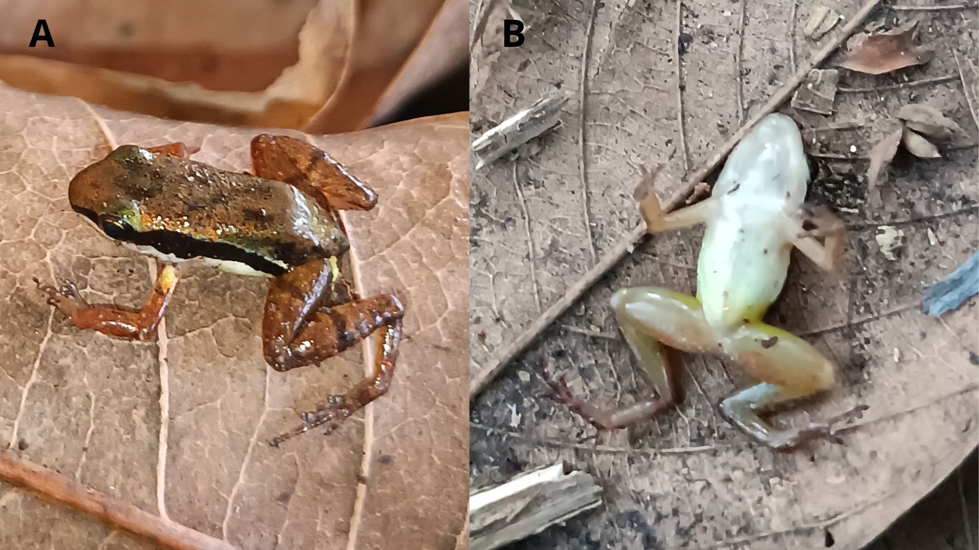

**Figure 1.** Unvouchered male specimen of the Atlantic Forest rocket-frog, *Allobates olfersioides*,photographed in the municipality of Amaraji, Pernambuco. A) Dorsal view and B) Ventral view.

The currently recognized geographic distribution of *A. olfersioides* extends over much of the eastern Atlantic Forest of Brazil, extending north from the state of Rio de Janeiro to the state of Alagoas (IUCN SSC 2023). However, some published records indicate the species is also present north of these locations, in the state of Pernambuco (SEMAS 2015; Oliveira et al. 2021). Evidence based on DNA sequences support that *A. olfersioides* is the sister group to a clade containing all other species of *Allobates*, which are predominantly distributed in the Amazon basin (Grant et al. 2006; Grant et al. 2017). Some studies also revealed extensive geographic variation in vocalizations (Forti et al. 2017b), DNA sequences (Grant et al. 2017) and tadpole morphology (Dubeux et al. 2020b) between *A. olfersioides* populations distributed in the southeast and northeast stretches of the Atlantic Forest, suggesting that more than one species may be currently recognized under the name *A. olfersioides*.

Although *A. olfersioides* is currently classified as endangered and in need of conservation action (SEMAS 2015; ICMBIO 2018), it has been subject to few ecological studies (Tinoco et al. 2008; Forti et al. 2017b; Costa et al. 2019). Costa et al. (2019) uncovered that increased air humidity and low air temperature are good predictors of their reproductive activity. As a species that depends on specific environmental conditions for its reproduction, destruction and degradation of rainforest habitats are likely the main threats to its conservation (IUCN ASG 2023).

In a context of uncertainty regarding the true distribution of a species in complex and unstable environment, an alternative to predict its occurrence and geographic range is the use of environmental suitability models (ESM). ESMs are models which estimate the areas with the highest potential for the occurrence of a taxonomic or phylogenetic entity based on ecological niche theory, using distribution records and environmental data to calculate the areas with the highest environmental suitabilty for a given entity (Soberón 2007; Elith & Leathwick 2009; Peterson & Soberón 2012; Guisan et al. 2018; Zurel et al. 2020). In recent years, ESM have played important roles in studies in ecology and conservation, with the aim of making predictions about species distributions useful to species management and conservation strategies (Svenning et al. 2011; Forti et al. 2017a; Sobral-Souza et al. 2018; González-Fernandez et al. 2022). The philopatric and stenoic nature of most anuran amphibians makes ESM an extremely useful tool for devising more accurate predictions of species distributions and aiding scientifically informed conservation planning (Dixo & Metzger 2010; Milanovich et al. 2012; da Silva et al. 2020).

In this study, we use an ESM approach to model the areas with the highest environmental potential for the occurrence of *A. olfersioides* in the Northeastern Atlantic Forest of Brazil. Additionally, we evaluate the overlap between our results and the latest species range map provided by the IUCN Red List of Threatened Species (IUCN SSC 2023). We also evaluate the overlap between modeled species distribution and the existing conservation units, which could potentially contribute to its conservation. We restrict our evaluation to habitats and species records of Northeastern Atlantic Forest north of the Doce River, a well-known biogeographic barrier for several groups of organisms (Marques et al. 2021; Pereira et al. 2022). Forest fragmentation has been historically more intense in the northeastern Atlantic Forest and geographic distribution of the species in most of the territory is highly uncertain. Also, by excluding southeastern populations from our analyses, we reduce the chance of producing a composite distribution model, resulting from the analysis of the environmental niches of distinct evolutionary lineages, with distinct ecological requirements and environments of occurrence.

Our initial predictions were: 1) Areas with highest environmental suitability for the occurrence of *A. olfersioides* are restricted to the Atlantic Forest, as the biome is limited to the west by dryer environments of the South American Dry Diagonal; 2) the current geographic distribution map of the species in northeastern Brazil (IUCN SSC 2023) does not accurately reflect the most suitable areas for the species occurrence, as it did not take into account occurrence records available in literature and in zoological collections not linked to online databases; 3) due to the reproductive mode of *A. olfersioides* and its stenoic ecology, and based on a few available ecological studies, the variables with the highest importance in ESM for this species will be terrain slope, forest cover, temperature and humidity; 4) most of the areas with the highest potential for the occurrence of the species are outside conservation units, based the fact that only 10% of the Atlantic Forest of northeastern Brazil are protected within parks, reserves or refuges (Almeida & Souza 2023).

# Materials And Methods

## ***Occurrence records***

We obtained 40 occurrence records of *Allobates olfersioides* from the following sources: the Global Biodiversity Information Facility (GBIF), Brazilian Biodiversity Information System (SiBBr) and SpeciesLink databases. We also searched for records in peer-reviewed literature and consulted curators of zoological collections for geographic data on available specimens, namely Coleção Herpetológica da Universidade Federal da Bahia (UFBA), Universidade Federal do Sul da Bahia (UFSB), Universidade Federal de Alagoas (UFAL), Coleção Herpetológica da Universidade Federal de Pernambuco (CHUFPE), and Universidade Federal do Rio Grande do Norte (UFRN). One additional record was made during fieldwork in the Municipality of Amaraji, State of Pernambuco, between June and December 2022 (see Results). GBIF data were collected using the *dismo* R package (Hijmans et al. 2023b). Additionally, queries were made directly to the GBIF online platform (GBIF 2023) to verify the existence of records not found by *dismo*. For SiBBr and SpeciesLink, the data were downloaded directly from searches on their online platform, searching for the term "Allobates", and selecting the occurrence records located in the Atlantic Forest biome of Northeastern Brazil. Literature data were obtained through searches in Google Scholar, using the search terms “Herpetofauna", "Allobates" and "Atlantic Forest", separately. Publications referring to studies carried out in the Brazilian Northeast were selected and the data on the occurrence of the species were obtained by reviewing the sections of methods and supplementary materials (S1). After careful revision of the data associated with the initial 40 occurrence records obtained by these methods, five were excluded as duplicate geographic records (i.e., voucher specimens proceeding from the same locality), resulting in 35 valid records.

.

## ***Environmental predictors***

For the model predictor variables, the bioclimatic variables from the WorldClim v.2.1 database were used (Fick & Hijmans 2017), as well as terrain slope data and Enhanced Vegetation Index (EVI) data (Huete et al. 2002). The WorldClim bioclimatic variables were obtained using the *geodata* R package (Hijmans 2023c), for the 0.5 arc-min resolution. Then, the data were cropped to the extension of the Brazilian Northeastern Region. For the terrain elevation data, altitude data were initially obtained with the *geodata* R package. Then, *terra* R package (Hijmans 2023a) was used to calculate the terrain slope.

We conducted Spearman's correlation analysis to evaluate the existence of collinearity among environmental predictors, using r = |0.7| as a criterion for identifying strong correlations (Supplemental Material, Figure S1). When predictors were highly correlated, we removed one from the analyses and kept the most biologically relevant, considering the ecology of *A. olfersioides*. The following variables were used in the subsequent analyses: Bio9 (Mean Temperature of Driest Quarter), Bio14 (Precipitation of Driest Month), Bio16 (Precipitation of Wettest Quarter), Bio18 (Precipitation of Warmest Quarter) and Bio19 (Precipitation of Coldest Quarter) from the WorldClim v.2.1 platform (Fick & Hijmans 2017), terrain slope and EVI. The choice of these variables was mainly based on the reproductive ecology and life cycle in *Allobates* frogs, which are primary or secondary rainforest dwellers, whose reproduction occurs in the rainy season and is dependent on the presence of rain pools, where males or females deposit their tadpoles to complete larval development (Lima et al. 2002; Menin et al. 2011; Psaukonis et al. 2014).

## ***Modelling procedures***

To avoid spatial autocorrelation among occurrence records of *A. olfersioides*, records located less than 150 km from another record were removed from analyses, using the *spThin* R package (Aiello-Lammens et al. 2015). This resulted in the selection of 16 occurrence records out of 35 initial records (Fig. 2).

The models were performed using the MaxEnt algorithm, implemented in the *sdm* R package (Naimi & Araujo 2016). The choice of the MaxEnt algorithm was based on the stenoic ecology of *A. olfersioides* and its philopatric and territorial behavior, since the algorithm has relatively low rates of commission errors (Phillips et al. 2006). Alternative algorithms are prone to extrapolate areas of environmental suitability and are less suitable in studies with conservation goals, where more conservative estimates of species distributions are preferred (Aliaga-Samanez et al. 2019; Zurel et al. 2020; Ballesteros-Barrera et al. 2022). The model was performed with 16 occurrence records, 1000 background points, 25% of the data for training stage, and five replicates, using the entire Brazilian Northeast Region as background area. This allowed the evaluation of the predictive models’ quality, as an adequate model for that species should not assume high environmental suitability in regions of the South American Dry Diagonal, such as in the Caatinga and Cerrado biomes. Finally, the five replicates were adjusted in a single model, based on the value of the prediction index of Area Under the ROC Curve (AUC) (Manel et al. 2002), using the ensemble() function of the *sdm* R package.

## ***Model evaluation***

We used AUC and True Skill Statistic (TSS) (Allouche et al. 2006) as criteria to estimate the models’ predictive accuracy, using the sdm() function, both implemented in the *sdm* R package. Then, an histogram was made with habitat suitability model pixels data. This analysis was performed to estimate the distribution of the habitat suitability model values and to evaluate which range of values was the most frequent. Possible interpretations of the result of this analysis would be:

1. Negative unimodal distribution: a small percentage of the areas in the Brazilian Northeast are suitable for the occurrence of *A. olfersioides*;
2. Gaussian distribution: a small and great percentage of the areas of the Brazilian Northeast are low and high suitable for ecological niche of *A. olfersioides*, but a high percentage of these areas have median suitability values;
3. Positive unimodal distribution: a large percentage of the areas of the Brazilian Northeast are suitable for the occurrence of *A. olfersioides*.

To estimate which variables were most important for the model we used the getVarImp() function of the *sdm* R package. In order to estimate which predictor generated the highest response in the model, an exploratory analysis of the response curve was performed, using the rcurve() function of *sdm*. This allowed us to evaluate what range of the predictors were associated with the highest values of environmental suitability predicted by the models.

**Allobates olfersioides *distribution***

The areas in the background with an environmental suitability ≥ 75% were transformed into a geospatial polygon file, through the *raster* (Hijimans 2023d) and *sf* R package. The choice of this threshold value was because it is a separation value with fewer omission errors and with fewer extrapolations to regions ecologically unsuitable for *A. olfersioides* (Supplemental Material, Figure S3).

We estimated the difference between the total area estimated as highly suitable for the occurrence of *A. olfersioides* by our resulting model and the geographic distribution of the species in the same region according to the latest map provided in IUCN’s Red List of Threatened Species (IUCN SSC 2023). Additionally, we calculated and evaluated the geographic overlap between these areas. Area polygons were calculated using the st_area() function of the *sf* R package, and then converted to km². Overlap between polygons was calculated based on their intersection using the st_intersection() function of *sf*. The same procedures were carried out for evaluating overlap between the predicted highly suitable areas for *A. olfersioides* and polygons representing the limits of conservation units in the Brazilian northeastern Atlantic Forest.

# Results

## ***Occurrence records***

A total of 35 occurrence records of *Allobates olfersioides* were found in the Brazilian Northeastern Region. SiBBr was the source with the highest number of geographically referenced records (18), followed by GBIF (11), SpeciesLink and literature data (4 records each - Dias et al. 2014; Dubeux et al. 2020a, Freitas et al. 2019; Oliveira et al. 2021). Zoological collections of UFPE and UFSB had one record each and one additional record was done in the field. Although additional specimens were present in zoological collections, those lacked detailed information on the geographic location where specimens were captured.

Geographic records of *A. olfersioides* covered rainforest remnants in four northeastern Brazilian states (Figure 2). Bahia was the state with the highest number of records, accounting for 20 locations, followed by Alagoas (9), Pernambuco (4), and Sergipe (2). Most records were in Atlantic rainforest fragments near the coast. One record proceeded form a highland forest in a transition area between the Atlantic Forest and the Caatinga biomes (Brejo dos Cavalos, Caruaru, Pernambuco). These records indicate that the northmost limit of the distribution of *A. olfersioides* is located within the state of Pernambuco. Latitude range of records varied between 17.07821 S° and 7.60389 S°, and longitude between 39.73417 W° and 35.24733 W°, mainly corresponding to areas originally covered by the Atlantic Forest and transition zones with the Caatinga biome.

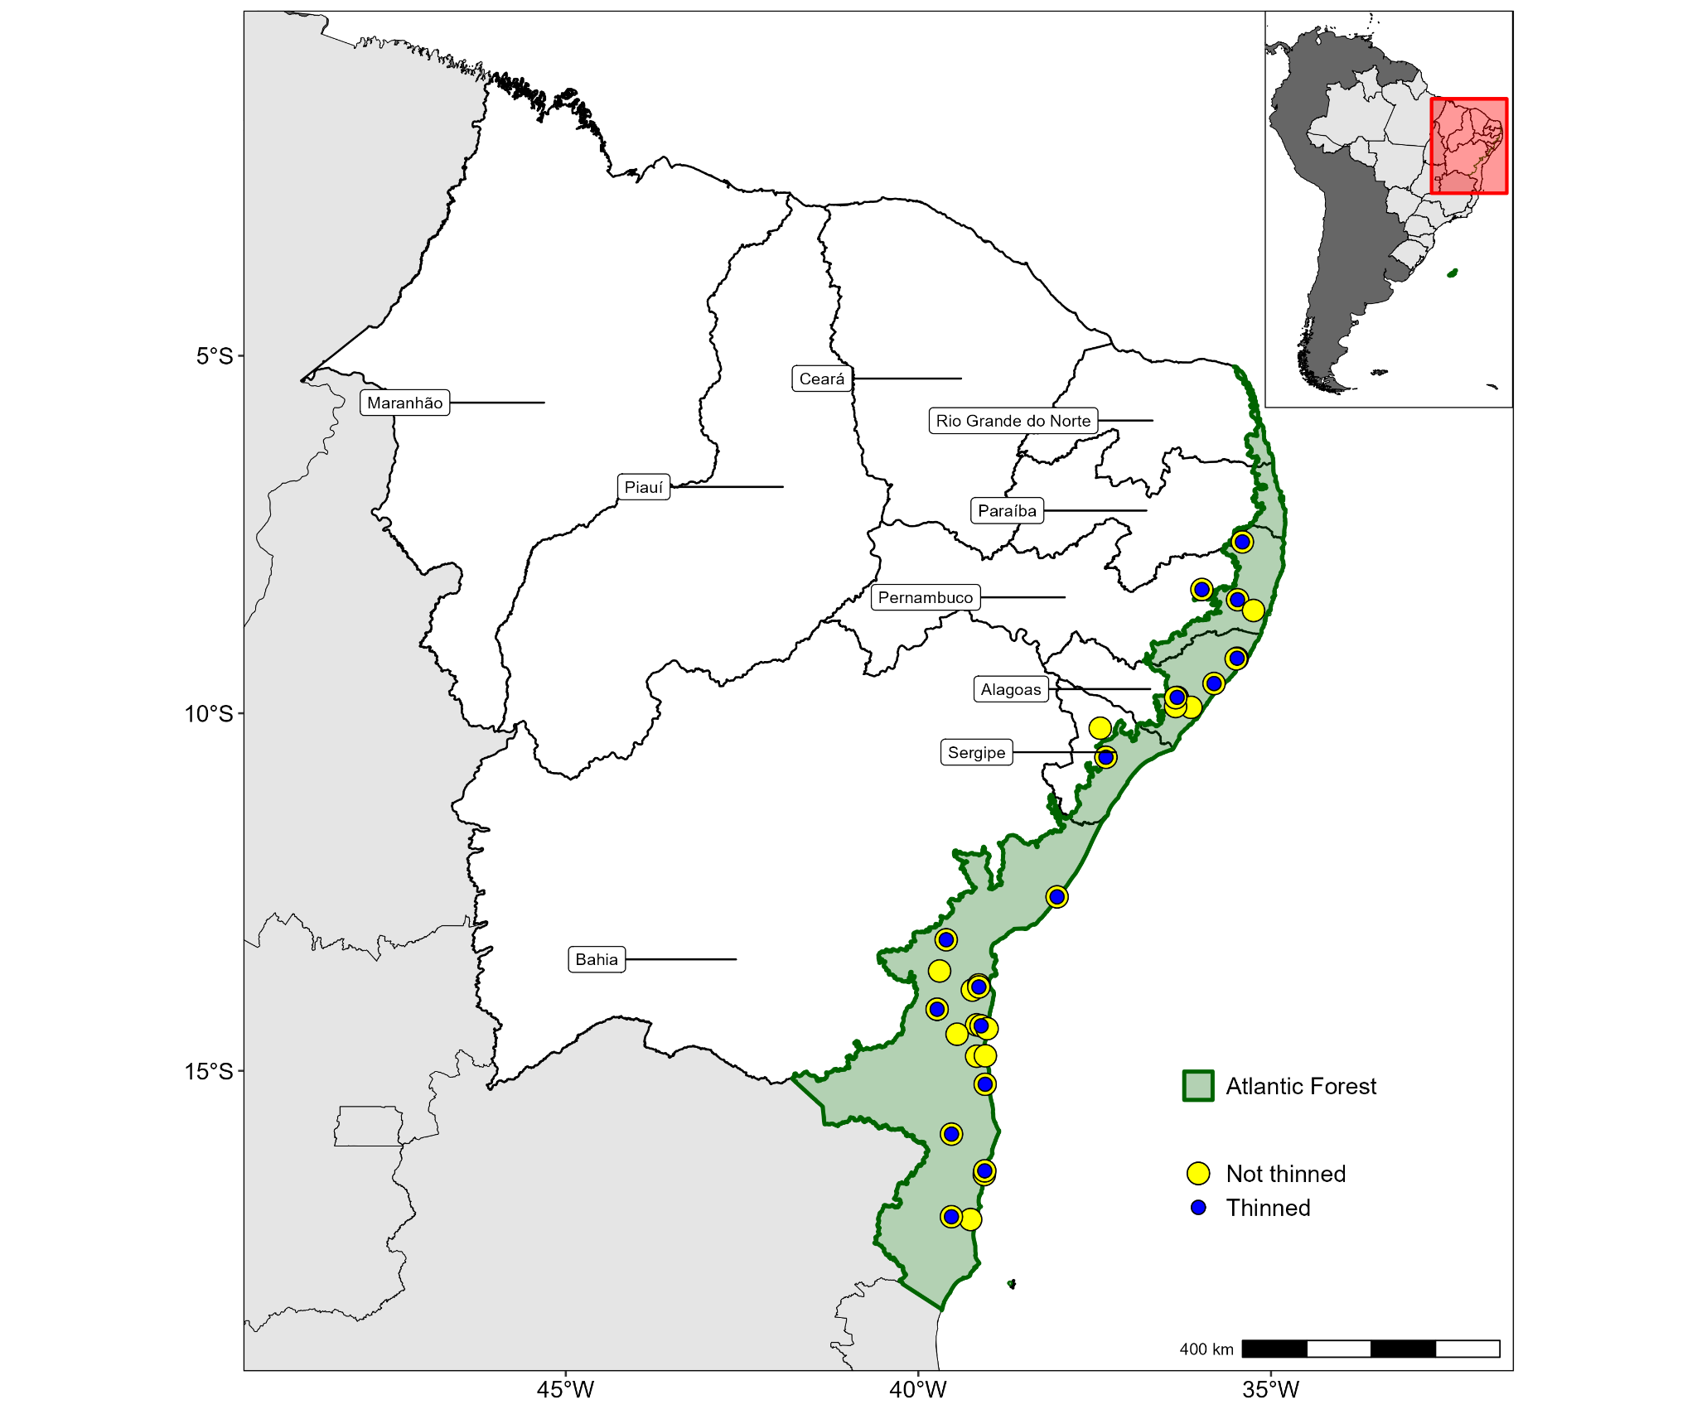

**Figure 2.** Occurrence records of *Allobates olfersioides* in the Brazilian Northeast. Yellow dots: Geographic records available in online databases, zoological collections and literature data. Blue dots: Records used in environmental suitability models, after evaluation of spatial autocorrelation. Green area: Original distribution of the Atlantic Forest vegetation in the region.

## ***Environmental suitability model***

The generated model had a 0.9 in AUC, indicating only a 10% error probability due to false negatives in the prediction. The model also had a 0.79 in TSS, indicating a better performance at generating true positives, than a random prediction model. The areas indicated as the most suitable for *A. olfersioides* based on environmental predictors were concentrated along the coast, within the Atlantic Forest biome (Figure 3). There were gaps between some of the areas with highest environmental suitability, with core areas of high suitability located along the central and northern coast of Bahia, along the southern coast of the state of Sergipe, and along the northern coast of Alagoas and southern coast of Pernambuco (Figure 3). Additional small patches of high environmental suitability were indicated in highlands located west of these core areas in Bahia, Paraíba, Rio Grande do Norte, and Ceará.

The distribution of suitability values was negative unimodal, indicating that a small percentage of the areas of the Brazilian Northeast are suitable for the occurrence of *A. olfersioides*. About 89% of the area covered by the model had low environmental suitability for the species (< 25%) (Supplemental Material, Figure S3a). The areas with environmental suitability ranging between 25–50%, 50–75% and > 75% represented 2.9%, 3.1% and 4.9% of the background area, respectively (Supplemental Material, Figure S3b). The areas with a high environmental suitability (> 75%) represent only about 3% of the area of the Northeast, distributed mainly at costal Atlantic.

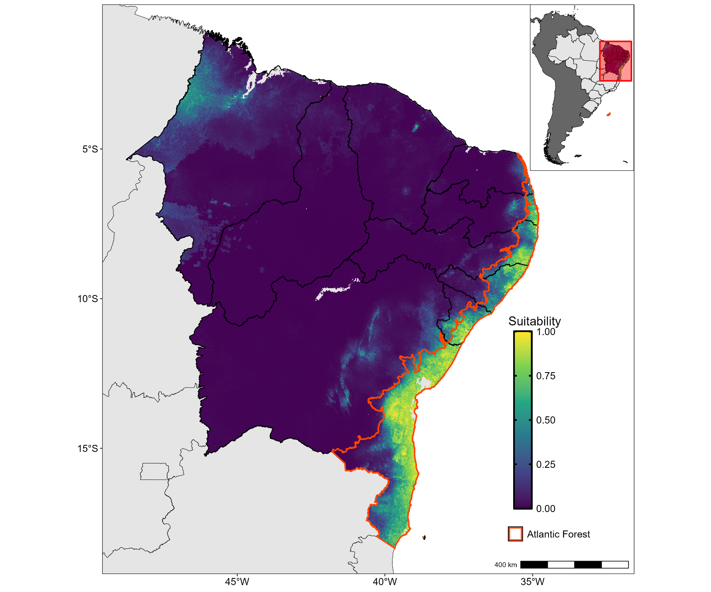

**Figure 3**. Environmental suitability model for *Allobates olfersioides* in the Brazilian Northeastern Region. Dark/purple areas: areas of low environmental suitability. Light/yellow areas: areas of high environmental suitability. Orange polygon: original distribution of the Atlantic Forest vegetation on Brazilian Northeastern Region.

The predictor variable most strongly associated with environmental suitability model was Bio14 (precipitation of the driest month), followed by Bio19 (precipitation of the coldest quarter of the year), Bio18 (precipitation of the warmest quarter), Slope, EVI, Bio9 (average temperature of the driest quarter of the year) and Bio16 (precipitation of the wettest quarter of the year) (Supplemental Material, Figure S4a). Bio14 had a 54% correlation with the environmental suitability predicted by the model. Bio19 and Bio19 had 44% and 6% correlation with the model’s response, respectively. Correlations between model’s response and the remaining predictors were always lower than 3%. Relationships between variables associated with precipitation (e.g., Bio14, Bio19, Bio 18) and the environment suitability model were always positive (Supplemental Material, Figure S4b). The temperature-related variable Bio9 had an inversely proportional relationship with the model’s response. The EVI and Slope variables did not contribute significantly to the model.

## ***Model’s high environmental suitability area evaluation***

By projecting a polygon of the areas with ≥ 75% of environmental suitability for the occurrence of *A. olfersioides* over the background study area, gaps between the environmental suitability cores expanded, and the area of high suitability in Chapada Diamantina was not maintained (Figure 4). This polygon had an area of 43,684.67 km². The species distribution polygon proposed by the IUCN for *A. olfersioides* has its northern latitudinal limit located at south coast of the state of Pernambuco, and its longitudinal limit was similar to that in our model’s polygon, suggesting the presence of *A. olfersioides* only in the Atlantic Forest domain (Figure 4). The area of the polygon proposed by IUCN as suitable for the occurrence of *A. olfersioides* is 58,693.89 km². Thus, our model suggests that the environmental suitability area for the species is approximately 25.6% smaller than previously thought. The intersection area between the model polygon and the IUCN polygon was 29,675.23 km² and approximately 49% of the IUCN polygon area does not coincide with areas of high environmental suitability indicated in our model. Approximately 32.1% of the polygon generated by our model was not encompassed by the IUCN’s polygon. These include forested areas along the coast of northern Bahia and southern Sergipe, and along the coast of Pernambuco and Paraíba, all areas with a high potential for the occurrence of *A. olfersioides*.

The conservation units present in the Atlantic Forest of Northeastern Brazil cover a total area of 14,282.68 km², extending north from southern Bahia to the state of Rio Grande do Norte (Figure 5). Overlap between areas currently included in conservation units and the polygon of high suitability for *A. olfersioides* was 7,094.17 km². This indicates that approximately 83.8% of the area with the highest suitabilityfor the species is located outside of conservation units. On the other hand, 49.66% of the area protected in conservation units encompassed areas of high environmental suitability for *A. olfersioides*, indicating that almost half the area preserved in these forest fragments have adequate environmental conditions for the species. Importantly, confirmed geographic records of *A. olfersioides* were found in only eight of the 226 conservation units included in the analysis (Table 1).

**Table 1.** Conservation units with records of occurrence of *Allobates olfersioides,* with information on the category of the conservation units, the number of records in that conservation units, the name of the conservation units and the state where it is located.

|  |  |  |  |  |
| --- | --- | --- | --- | --- |
| State | Municipality | Source | Thinned | Conservation Unity |
| Bahia | Itacaré | GBIF | Yes | Costa de Itacaré/ Serra Grande Environmental Protection Area |
| Bahia | Itamaraju | SiBBR | No | Descobrimento National Park |
| Bahia | Una | SiBBR | Yes | Una Biological Reserve |
| Bahia | Itacaré | SiBBR | No | Costa de Itacaré/ Serra Grande Environmental Protection Area |
| Bahia | Wenceslau Guimarães | SiBBR | No | Caminhos ecológicos da Boa esperança Environmental Protection Area |
| Alagoas | Maceió | Dubeux et al. 2020 | No | Catolé e Fernão Velho Environmental Protection Area |
| Pernambuco | Timbaúba | Oliveira et al. 2021 | No | Wildlife Refuge Matas de Água Azul |
| Bahia | Ilhéus | SpeciesLink | No | Private Reserve of Natural Heritage Fazenda Arte Verde |

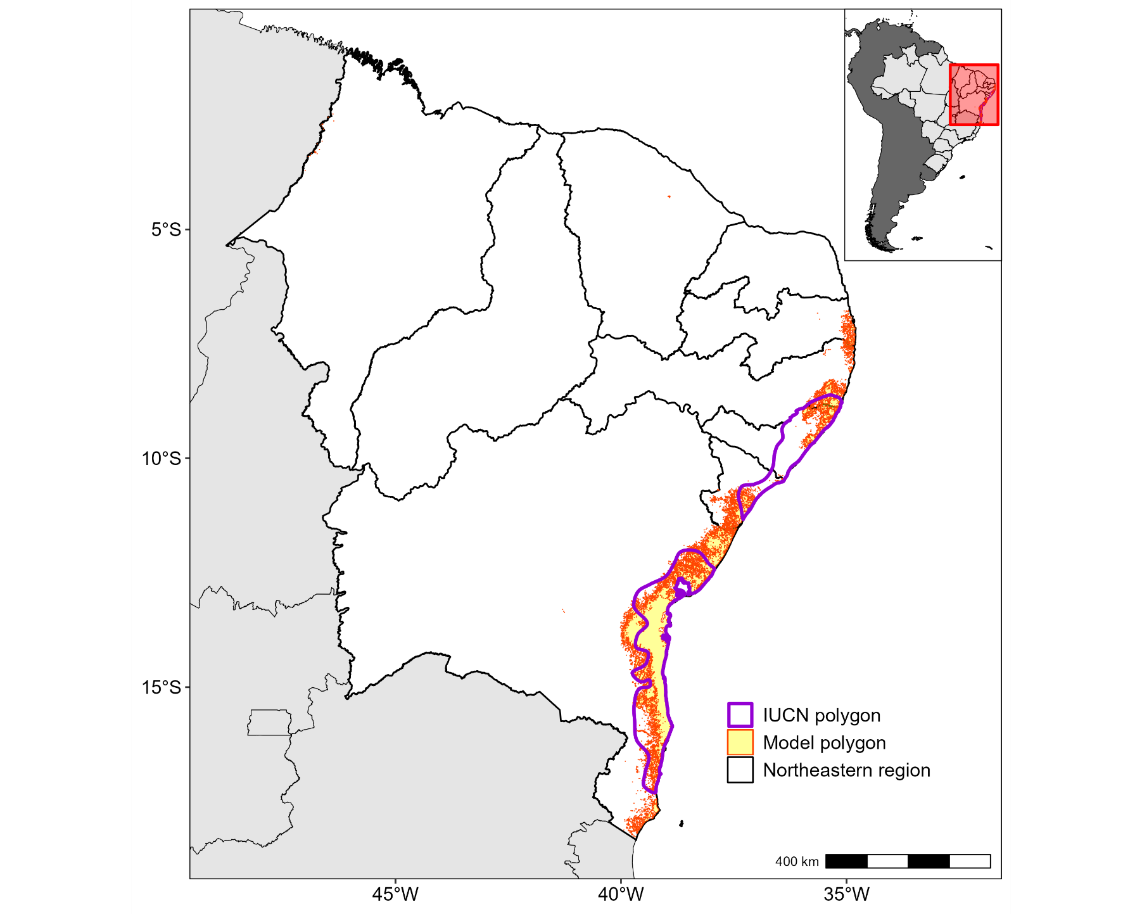

Figure 4. Geographic range differences between the model polygon areas with environmental suitability ≥ 75% and the distribution proposed by the IUCN polygon (IUCN SSC 2023).

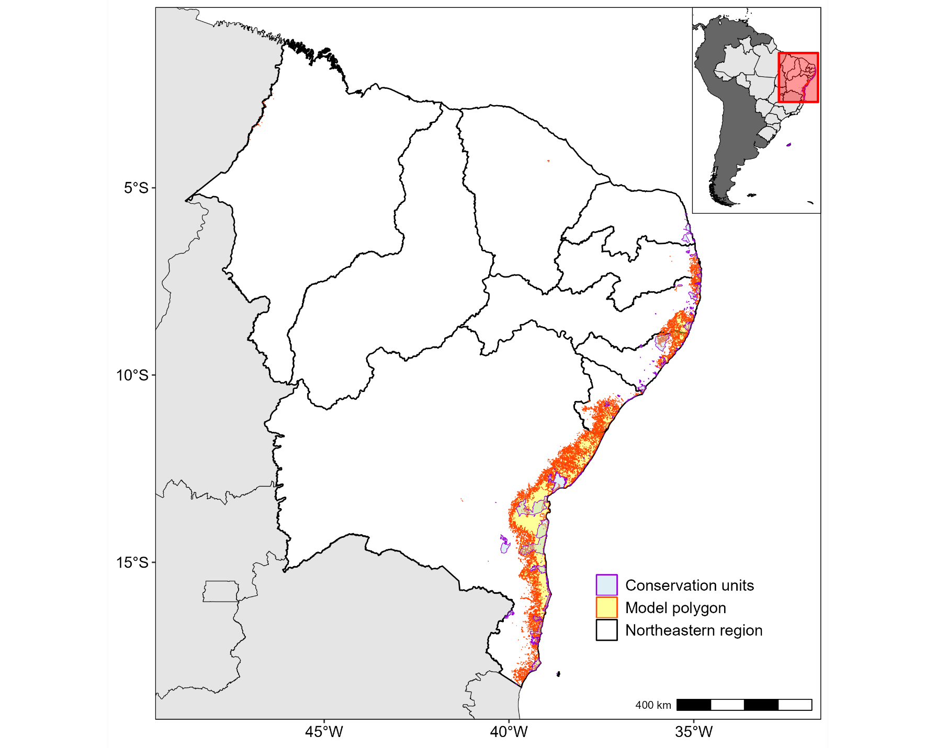

Figure 5. Geographic range differences between the model polygon areas with environmental suitability ≥ 75% and the of conservations units in northeastern Atlantic Forest.

# Discussion

Geographic records of *A. olfersioides* across the Brazilian northeastern Atlantic Forest are currently discontinuous, with regions with higher concentrations of records and relatively wide distribution gaps (Figure 2; Supplemental Material, Figure S5). Part of the scarcity of records may be due to the lack of fieldwork specifically aimed at monitoring and detecting populations of diurnal, litter-dwelling frogs. Another potential reason is the intense past and current fragmentation of the Atlantic Forest, which left forest habitats mainly restricted to small forest patches (Lira et al. 2021). More than half of the records detected in our survey (19) were spatially structured, located within less than 150 km from each other. As most forest fragments are sparse and with little connectivity among them (Tabarelli et al. 2004; Tabarelli et al. 2010; Muylaert et al. 2018), wide geographic regions exist with a low concentration of records, whereas records of *A. olfersioides* tend to be concentrated in the same locations, where forest fragments may harbor isolated populations. Fieldwork specially targeted at the detection of diurnal frogs in forest habitats in in poorly sampled areas along the coast of northeastern Brazil will help clarifying whether geographic distribution gaps of *A. olfersioides* are an artifact of reduced sampling effort or a consequence of historical habitat fragmentation and degradation.

Environmental predictors indicating increased precipitation and milder temperatures were the most strongly associated with areas with high environmental suitability for *A. olfersioides*. As ectotherms, amphibians depend on environmental temperature and humidity to regulate their metabolism and to adjust their ecophysiological performance (Bakken & Anguilletta JR 2013). In tropical rainforest habitats, forest edges and open vegetation surrounding forest remnants can represent physiologically challenging habitats for forest-specialist organisms (Dixo & Metzger 2010; Almeida-Gomes & Rocha 2014; Almeida-Gomes & Rocha 2015). As these species depend on specific microclimatic conditions, they usually inhabit the core area of forest fragments ([Ramalho et al. 2021](https://www.sciencedirect.com/science/article/pii/S0006320721002391?via%3Dihub); Mantavelli et al. 2022). This is especially important for amphibian species of small body size, such as *A. olfersioides*, because they are relatively more susceptible to dehydration (Vitt & Caldwell 2013). Thus, it is expected that areas with lower temperatures in the driest months of the year will present higher environmental suitability for *A. olfersioides*. In addition, *A. olfersioides*’ reproduction relies on the presence of rain pools for larval development (Costa et al. 2019). In general, seasons of higher precipitation coincide with the reproductive period of most anuran species in the northeastern Atlantic Forest (Lourenço-de-Moraes et al. 2019), and different precipitation patterns are strong environmental modulators in the distribution of anuran amphibians in the biome (Vasconcelos et al. 2014). A greater number of *A. olfersioides* males vocalizing during periods of increased relative humidity has already been reported (Costa et al. 2019).

EVI and terrain slope had a minor influence on environmental suitability for *A. olfersioides*, not confirming our initial hypotheses. EVI was selected as one of the main environmental predictors a priori due to the stenoic habit of *A. olfersioides*, and areas with high EVI can be generally interpreted as areas with denser vegetation cover (Silva et al. 2021). Slope was selected as a proxy for the potential presence of flat terrain, prone to accumulate rainwater in pools. The low performance of EVI in our model may be an artifact of data resolution. Because EVI data is provided in 0.5 arc-min resolution, each pixel represents an area of 1 km² and the index value represents a summarized value of the whole vegetation coverage. Several forest fragments in the northeastern Atlantic Forest cover areas smaller, or not much larger than 1 km², and open vegetation (sugarcane monoculture, pasture, etc.) surrounding the fragments reduce the EVI estimated for each pixel (Dong et al. 2013; Oon et al. 2023; Supplemental Material, Figure S6).

In relation to slope, Amazonian species of *Allobates* occupy environments with specific terrain inclination (Lima et al. 2002; Rocha et al. 2018; but see Menin et al. 2011). It is possible that flat environments flood more easily in rainy periods, not allowing the formation of isolated rain pools. On the other hand, steep environments retain less rainwater, making it difficult for water ponds to form. Thus, *A. olfersioides*, as well as other species of Dendrobatoidea group, will prefer specific microenvironments, perhaps existing in terrains with different slopes, which favor the formation of small pools. As each slope datum value in our analysis also represents a summary of an area of 1 km², and that *A. olfersioides*’ home range is much smaller than that (Costal et al. 2023), slope data resolution possibly did not capture terrain variation which is biologically relevant to our study species (Supplemental Material, Figure S7).

The geographic distribution of *A. olfersioides* as proposed by the latest update IUCN’s Red List of Threatened Species (IUCN SSC 2023) was marginally inconsistent with geographic records available for the species and with our environmental suitability model. IUCN’s species range map indicates the northern latitudinal limit of distribution of *A. olfersioides* as not extending beyond southern state of Pernambuco. However, occurrence records exist for the species in localities north of the proposed limit (SEMAS 2015; Oliveira et al. 2021; supplementary material, Table S1). IUCN’s species distribution maps are among the most important conservation tools used by biodiversity researchers (Cassin et al. 2011; da Silva et al. 2020). However, they apparently do not capture all geographic record information available. Accounting for all available records is necessary to avoid the exclusion of areas bearing known populations from conservation planning. Our results suggest that the area environmentally suitable to *A. olfersioides* can be 25% smaller than that predicted by IUCN’s species distribution map (IUCN SSC 2023). The reduction of areas that favor the survival of more sensitive species, such as forest-specialists, may generates projections more restricted than potential projections, such as proposed by IUCN (IUCN SSC 2023), by discriminating areas with greater and lesser environmental suitability in those habitats (Becker et al. 2010; Dixo & Metzger et al. 2010). Considering the biology and ecophysiological needs of *A. olfersioides* and the current scenario of the Atlantic Forest degradation (Lôbo et al. 2011; Costa et al. 2019; Lira et al. 2021), we can expect its actual distribution can be more restricted than previously proposed, such as IUCN model used by this work (IUCN SSC 2023).

Only 16% of the area of high environmental suitability for *A. olfersioides* is located within conservation units. This can be explained in part by the scarcity of conservation units in the Brazilian northeastern Atlantic Forest and by their relatively small size and sparse geographic distribution (Almeida & Souza 2023) (Figure 7). However, few records of the species come from fieldwork conducted within conservation units, and true absences are hard to confirm until sampling effort is increased. Based on the available information, most of the areas with great potential for the conservation of *A. olfersioides* and their most favorable ecosystems also need to receive attention outside the conservation units, as well as management plans that anticipate anthropogenic interference (Nori et al. 2018; Lins-e-Silva et al. 2021). One of the records in the state of Pernambuco, in the municipality of Amaraji (Supplemental Material, Table S1) was collected in a forest fragment with about 200 m², surrounded by a sugarcane and banana plantations, suggesting that the species can survive in small forest patches when adequate microclimatic conditions are present.

On the view of the conservation of the species, a fraction of the efforts should be focused on the conservation of these most threatened fragments, as well as the creation of ecological corridors between the fragments in these areas (Calmon et al. 2011; Santos et al. 2018; Campos et al. 2020), such mosaic landscapes would potentially allow for increased dispersion and gene flow among populations inhabiting neighbor fragments, thus reducing the cumulative effects of habitat fragmentation and reproductive isolation and inbreeding on the remaining populations of *A. olfersioides*.

# Acknowledgments

We thank the curators of herpetological collections of Universidade Federal da Bahia, Universidade Federal do Sul da Bahia, Universidade Federal de Alagoas and Universidade Federal do Rio Grande do Norte for sharing information on geographic records. We thank Pedro A. C. L. Pequeno and Maurício H. Vancine for their valuable help in data analyses. We thank the Furtunato family for granting us access to study areas within their farm.

# Disclosure statement

The authors report no potential conflict of interest.

# Funding

ENMSJr and PBMjr received scholarships from Brazilian Coordenação de Aperfeiçoamento de Pessoal de Nível Superior (CAPES #88887.937961/2024-00 and CAPES #88887.485655/2020-00) while conducting work related to this study.

# Orcid

Edson Nilton de Moura Silva-Júnior: <https://orcid.org/0009-0003-9116-2020>

Paulo Braga Mascarenhas-Júnior: <https://orcid.org/0000-0002-1292-9904>

Victor Leandro-Silva: <https://orcid.org/0000-0001-9985-5532>  
Pedro Ivo Simões: <https://orcid.org/0000-0002-1651-7456>

# References

Aiello-Lammens ME et al. 2015. spThin: an R package for spatial thinning of species occurrence records for use in ecological niche models. Ecography. 38: 541-545

Aliaga-Samanez A, Real R, Vermmeer J, Oliveiro J. 2019. Modelling species distributions limited by geographical barriers: A case study with African and American primates. Global Ecology and Biogeography. 29(3): 444-453

Allouche O, Tsoar A, Kadmon R. 2006. Assessing the accuracy of species distribution models: prevalence, kappa and the true skill statistic (TSS). Journal of Applied Ecology. 43(6): 223-1232

Almeida AM, Souza AF. 2023. Northern Atlantic Forest: Conservation Status and Perspectives. In: Filho GAP, França FGR, Alves RRN, Vasconcellos A, editors. Animal Biodiversity and Conservation in Brazil's Northern Atlantic Forest. New York: Springer. p. 19-20

Almeida-Gomes M, Rocha CFD. 2015. Habitat Loss Reduces the Diversity of Frog Reproductive Modes in an Atlantic Forest Fragmented Landscape. Biotropica. 47(1): 113-118

Almeida-Gomes M, Rocha CFD. 2014. Landscape connectivity may explain anuran species distribution in an Atlantic Forest fragmented area. Landscape Ecology. 29: 29-40

AppEEARS. (2023). AppEEARS (Application for Extracting and Exploring Analysis Ready Samples). Disponível em <<https://lpdaacsvc.cr.usgs.gov/appeears/>>

Bakken GS, Angilletta Jr MJ. 2013. How to avoid errors when quantifying thermal environments. Functional Ecology. 28(1): 96-107

Ballesteros-Barrera C et al. 2022. The Potential Effect of Climate Change on the Distribution of Endemic Anurans from Mexico’s Tropical Dry Forest. Diversity. 14(8): 650

Becker CG, Loyola R, Haddad C, Zamudio K. 2010. Integrating species life-history traits and patterns of deforestation in amphibian conservation planning. Diversityand Distributions. 16(1): 10-19

Bokermann WCA. 1967. Novas espécies de Phyllobates do leste e sudeste brasileiro (Anura, Dendrobatidae). Revista Brasileira de Biologia. 27: 349–353

Calmon M et al. 2011. Emerging Threats and Opportunities for Large-Scale Ecological Restoration in the Atlantic Forest of Brazil. Restauration ecology. 19(2): 154- 158

Campos FS et al. 2020. Searching for Networks: Ecological Connectivity for Amphibians Under Climate Change. Environmental Management. 65: 46-61

CAMPOS, F. S., et al. Threatened amphibians and their conservation status within the protected area network in northeastern Brazil. Herpetol, v.47, n.2, p.277-285, 2013

Carlucci MB, Marcilio-Silva V, Torezan JM. 2021. The Southern Atlantic Forest: Use, Degradation, and Perspectives for Conservation. In: In: Marques M, Grelle CO. The Atlantic Forest: History, Biodiversity, Threats and Opportunities of the Mega-Diverse Forest. Cham: Springer. 2021. p.91–111

Carnaval, ACOQ, Puschendorf R, Peixoto O, Verdade V, Rodrigues M. 2006. Amphibian chytrid fungus broadly distributed in the brazilian atlantic rain forest. EcoHealth. 3(1): 41–48

Cassin MH. 2011. Ranking threats using species distribution models in the IUCN Red List assessment process. Biodiversity and Conservation. 20: 3689–3692

Castro DF, Rodrigues J, Borges-Leite M, Lima D, Nojosa D. 2019. Anuran diversity indicates that Caatinga relictual Neotropical forests are more related to the Atlantic Forest than to the Amazon. Biodiversity and Conservation. 6: e6208

Colombo AF, Joly CA. 2010. Brazilian Atlantic Forest lato sensu: the most ancient Brazilian forest, and a biodiversity hotspot, is highly threatened by climate change. Braz. J. Biol. 70(3): 697–708

Costa LP. 2003. The historical bridge between the Amazon and the Atlantic Forest of Brazil: a study of molecular phylogeography with small mammals. Journal Of Biogeography. 30(1): 71–86

Costa SM, Dias E. 2019. Comportamento territorial, vocalização e biologia reprodutiva de *Allobates olfersioides* (Anura: Aromobatidae). Iheringia, Série Zoologia. 109: e2019031

da Silva FP, Fernandes-Ferreira H, Montes M, da Silva L. 2020. Distribution modeling applied to deficient data species assessment: A case study with Pithecopus nordestinus (Anura, Phyllomedusidae). Neotropical Biology and Conservation. 15(2): 165–175

Dias IB, Mira-Mendes C, Solé M. 2014. Rapid inventory of herpetofauna at the APA (Environmental Protection Area) of the Lagoa Encantada and Rio Almada, Southern Bahia, Brazil. Herpetology Notes. 7: 627–637

Dixo M, Metzger JP. 2010. The matrix-tolerance hypothesis: an empirical test with frogs in the Atlantic Forest. Diversity and Conservation. 19: 3059–3071

Dong J et al. 2013. Mapping deciduous rubber plantations through integration of PALSAR and multi-temporal Landsat imagery. Remote Sensing Environment. 134: 392–402

Dubeux MJM, Gonçalves U, Nascimento FA, Mott t. 2020a. Anuran amphibians of a protected area in the northern Atlantic Forest with comments on topotypic and endangered populations. Herpetology Notes. 13: 61–74

Dubeux MJM et al. 2020b. Morphological characterization and taxonomic key of tadpoles (Amphibia: Anura) from the northern region of the Atlantic Forest. Biota Neotropica. 20(2): e20180718

Elith J, Leathwick JR. 2009. Species Distribution Models: Ecological Explanation and Prediction Across Space and Time. Annual Review of Ecology, Evolution, and Systematics. 40(1): 677–697

Ferreira RB, Beard K, Crump M. 2016. Breeding Guild Determines Frog Distributions in Response to Edge Effects and Habitat Conversion in the Brazil’s Atlantic Forest. PloS ONE. 11(6): e0156781

Fick SE, Hijmans RJ. 2017. WorldClim 2: new 1km spatial resolution climate surfaces for global land areas. [International Journal of Climatology. 37(12):](https://rmets.onlinelibrary.wiley.com/doi/abs/10.1002/joc.5086) [4302–4315](https://rmets.onlinelibrary.wiley.com/doi/abs/10.1002/joc.5086)

Forti LR et al. 2017a. Perspectives on invasive amphibians in Brazil. PloS ONE. 12(9): e0184703

Forti LR, da Silva T, Toledo L et al. 2017b. The acoustic repertoire of the Atlantic Forest Rocket Frog and its consequences for taxonomy and conservation (Allobates, Aromobatidae). ZooKeys. 692: 141–153

Freitas MA et al. 2019. Herpetofauna of Serra do Timbó, an Atlantic Forest remnant in the State of Bahia, Northeasternearnern Brazil. Herpetology Notes. 12: 245–260

GLOBAL BIODIVERSITY INFORMATION FACILITY (GBIF). Disponível em: <https://[www.gbif.org/](http://www.gbif.org/) >. Acesso em: 03 de julho de 2023.

González-Fernandez A, González-Fernandez C, Sunny A, Ruíz-Gutiérrez F, Chávez C. 2022. Determination of priority areas for amphibian conservation in Guerrero (Mexico), through systematic conservation planning tools. Journal of Nature Conservation. 68: 126235

Grant T et al. 2006. Phylogenetic Systematics Of Dart-Poison Frogs And Their Relatives (Amphibia: Athesphatanura: Dendrobatidae). Bulletin of the American Museum of Natural History. 299: 1–262

Grant T et al. 2017. Phylogenetic Systematics of Dart-Poison Frogs and Their Relatives Revisited (Anura: Dendrobatoidea). BioOne. 12(1): 1–90

Grelle CEV et al. Conservation Initiatives in the Brazilian Atlantic Forest. In: Araujo TB, Araujo, T. P. The Atlantic Forest: History, Biodiversity, Threats and Opportunities of the Mega-Diverse Forest. Cham: Springer. 2021. p. 421–449

Guisan A. et al. Overview of the Habitat Suitability Modeling Procedure. In: Habitat Suitability and Distribution Models With Applications in R. Cambridge: Cambridge. 2018. p.11–20

Hijmans RJ (2023a). _terra: Spatial Data Analysis_. R package version 1.7-29, <https://CRAN.R-project.org/package=terra>

Hijmans, RJ. et al. (2023b). _dismo: Species Distribution Modeling_. R package version 1.3-14, [https://CRAN.R-project.org/package=dismo](https://cran.r-project.org/package%3Ddismo)

Hijmans, RJ et al. (2023c). _{geodata}: Download Geographic Data_. R package version 0.5-8, [https://CRAN.R-project.org/package={geodata}](https://cran.r-project.org/package%3Dgeodata)

Hijmans RJ (2023d). _raster: Geographic Data Analysis and Modeling_. R package version 3.6-26, [https://CRAN.R-project.org/package=raster](https://cran.r-project.org/package=raster)

Huete A et al. 2002. Overview of the radiometric and biophysical performance of the MODIS vegetation indices. Remote Sensitive Environment. 83(1-2): 192–213

ICMBIO. 2018. Fauna Brasileira Ameaçada de Extinção. Fundação Biodiversitas para a Conservação da Diversidade Biológica, Brasília

IUCN ASG: [**IUCN SSC Amphibian Specialist Group**](https://www.iucn-amphibians.org/). < <https://www.iucn-amphibians.org/>>

IUCN SSC Amphibian Specialist Group & Instituto Boitatá de Etnobiologia e Conservação da Fauna. 2023. Allobates olfersioides. The IUCN Red List of Threatened Species 2023: e.T55122A117548027. <https://dx.doi.org/10.2305/IUCN.UK.2023-1.RLTS.T55122A117548027.en>

Kaefer IL, Montanarin A, da Costa R, Lima AP. 2012. Temporal Patterns of Reproductive Activity and Site Attachment of the Brilliant-Thighed Frog Allobates femoralis from Central Amazonia. BioOne. 46(4): 549­­–554

Kissel AM, Palen W, Ryan N, Adams M. 2018. Compounding effects of climate change reduce population viability of a montane amphibian. Ecological Applications. 29(2): e01832

Lima AP, Caldwell J, Biavati G. 2002. Territorial and Reproductive Behavior of an Amazonian Dendrobatid Frog, *Colostethus caeruleodactylus*. American Society of Ichthyologists and Herpetologists. 2002(1): 44–51

Lins-e-Silva ACB, Ferreira P, Rodal M: The North-Eastern Atlantic Forest: Biogeographical, Historical, and Current Aspects in the Sugarcane Zone. In: Marques M, Grelle CO. The Atlantic Forest: History, Biodiversity, Threats and Opportunities of the Mega-Diverse Forest. Cham: Springer. 2021. p.45–61

Lira PK, Portela R, Tambosi L: Land-Cover Changes and an Uncertain Future: Will the Brazilian Atlantic Forest Lose the Chance to Become a Hopespot?. In: Marques MCM, Grelle CEV. The Atlantic Forest: History, Biodiversity, Threats and Opportunities of the Mega-Diverse Forest. Cham: Springer. 2021. p.233–251

Lôbo, D, Leão T, Melo F, Santos A, Tabarelli M. 2011. Forest fragmentation drives Atlantic forest of Northeasternearnern Brazil to biotic homogenization. Diversity and Distributions. 17(2): 287–296

Lourenço-de-Moraes R et al. 2019. Functional traits explain amphibian distribution in the Brazilian Atlantic Forest. Journal of Biogeography. 47(1): 275–287

Manel S, Williams H, Ormerod S. 2002. Evaluating presence–absence models in ecology: the need to account for prevalence. Journal of Applied Ecology. 38(5): 921–931

Mantavelli R, Oliveira J, Soininen J, Ribeiro M, Bertoluci J. 2022. Altitude and temperature drive anuran community assembly in a Neotropical mountain region. Biotropica. 54(3): 607–618

Marques M, Trindade W, Bohn A, Grelle C: The Atlantic Forest: An Introduction to the Megadiverse Forest of South America. In: Marques M, Grelle CEV. The Atlantic Forest: History, Biodiversity, Threats and Opportunities of the Mega-Diverse Forest. Cham: Springer. 2021. p.3-23.

Melo FPL et al. 2013. Priority setting for scaling-up tropical forest restoration projects: Early lessons from the Atlantic Forest Restoration Pact. Environmental Science of Policy. 33: 395–404

Menin M, Waldez F, Lima AP. 2011. Effects of environmental and spatial factors on the distribution of anuran species with aquatic reproduction in central Amazonia. The Herpetological Journal. 21(4): 255–261

Milanovich JR, Peterman W, Barrett K, Hopton M. 2010. Do species distribution models predict species richness in urban and natural green spaces? A case study using amphibians. Landscape and Urban Planning. 107(4): 409–418

Muylaert RL et al. 2018. A note on the territorial limits of the Atlantic forest. Oecol Aust. 22(3): 302–311

Myers N, Mittermeier R, Mittermeier C, da Fonseca G, Kent J. 2000. Biodiversity hotspots for conservation priorities. Nature. 403: 853–858

Naimi B, Araújo MB. 2016. sdm: a reproducible and extensible R platform for species distribution modelling. Ecograph. 39(4): 368–375

Nori J, Villalobos F, Loyola R. 2018. Global priority areas for amphibian research. Journal of Biogeography. 45(11): 2588–2594

Oliveira PMA et al. 2021. Herpetofauna of Matas de Água Azul, an Atlantic Forest remnant in Serra do Mascarenhas, Pernambuco state, Brazil. Biotaneotropica. 21(2): e20201063

Oon A et al. 2023. The conservation of biodiverse continuous forests and patches may provide services that support oil palm yield: Evidence from satellite crop monitoring. Cleaner Production Letters. 4: 100036

Ortega-Chinchilla JE et al. 2022. Behavioral models of hydrothermal regulation in anurans: A field study in the Atlantic Forest, Brazil. Biotropica. 55(3): 329–338

Pasukonis A, Loretto MC, Landler L, Ringler M, Höfil W. 2014. Homing trajectories and initial orientation in a Neotropical territorial frog, *Allobates femoralis* (Dendrobatidae). Frontiers in Zoology. 11(29)

Pereira EA, Ceron K, Silva HR, Santana DJ. 2022. The dispersal between Amazonia and Atlantic Forest during the Early Neogene revealed by the biogeography of the treefrog tribe Sphaenorhynchini (Anura, Hylidae). Ecology and Evolution. 12(4): e8754

Peterson AT, Soberón J. 2012. Species Distribution Modeling and Ecological Niche Modeling: Getting the Concepts Right. Natureza e Conservação. 10(2): 102–107

Phillips SJ, Andersen R, Schaipire R. 2006. Maximum entropy modeling of species geographic distributions. Ecological Modelling. 190(3-4): 231–259

R Core Team (2023). _R: A Language and Environment for Statistical Computing_. R Foundation for Statistical Computing, Vienna, Austria. <[https://www.R-project.org/](https://www.r-project.org/)>

Ramalho Q, Tourinho L, Almeida-Gomes M, Vale M, Prevedello J. 2021. Reforestation can compensate negative effects of climate change on amphibians. Biological Conservation. 260: 109187

Réjaud A et al. 2020. Historical biogeography identifies a possible role of Miocene wetlands in the diversification of the Amazonian rocket frogs (Aromobatidae: Allobates). Journal of Biogeography. 47(11): 2472–2482

Ribeiro Jr. JW, Siqueira T, Brejão GL, Zipkin EF. 2018. Effects of agriculture and topography on tropical amphibian species and communities. Ecological Applications. 28(6): 1554–1564

da Rocha SMC, Lima AP, Kaefer I. 2018. Reproductive Behavior of the Amazonian Nurse-Frog *Allobates paleovarzensis* (Dendrobatoidea, Aromobatidae). South American Journal of Herpetology. 13(3): 260-270

Romanelli JP et al. 2022. Biodiversity responses to restoration across the Brazilian Atlantic Forest. Science of the Total Environment. 821: 153403

Santos JC et al. 2014. Aposematism increases acoustic diversification and speciation in poison frogs. Proc. R. Soc. B. 281(1796): 20141761

Santos JS et al. 2018. Delimitation of ecological corridors in the Brazilian Atlantic Forest. Ecological Indicators. 88: 414–424

Semas. 2015. Resolução SEMAS Nº 1 de 09 de janeiro de 2015. Reconhece como espécies de anfíbios da fauna pernambucana ameaçadas de extinção aquelas constantes da lista oficial e dá outras providências. Diário Oficial do Estado de Pernambuco, Jan/09/2015.

Silva FR, Oliveira T, Gibbs J, Rossa-Feres D. 2012. An experimental assessment of landscape configuration effects on frog and toad abundance and diversity in tropical agro-savannah landscapes of southeastern Brazil. Landscape Ecology. v.27, p.87–96

Silva RG et al. 2021. Vegetation trends in a protected area of the Brazilian Atlantic forest. Ecological Engineering. 162: 106180

Sistema de Informações sobre a Biodiversidade Brasileira (SiBBr). Disponível em: <[https://SiBBr.gov.br/](https://sibbr.gov.br/)>. Acessado em 03 de Julho de 2023

Soberón J. 2007. Grinnellian and Eltonian niches and geographic distributions of species. Ecology Letters. 10(12): 1115–1123

Sobral-Souza T, Vancine M, Ribeiro M, Lima-Ribeira M. 2018. Efficiency of protected areas in Amazon and Atlantic Forest conservation: A spatio-temporal view. Acta Oecologia. 87: 1–7

Solózarno A, Brasil LSCA, Oliveira RR: The Atlantic Forest Ecological History: From Pre-colonial Times to the Anthropocene. In: Marques M, Grelle CO. The Atlantic Forest: History, Biodiversity, Threats and Opportunities of the Mega-Diverse Forest. Cham: Springer. 2021. p.25–44

SpeciesLink. Disponível em: < <https://specieslink.net/>>. Acessado em 03 de Julho de 2023

STRASSBURG, B. B. N. et al. Global priority areas for ecosystem restoration. **Nature**, v.586, p.724-729, 2020

Svenning JC et al. 2011. Applications of species distribution modeling to paleobiology. Quaternary Science Reviews. 30(21-22): 2930–2947

Tabarelli M, Pinto L, Silva J, Hirota M, Bedê L. 2005. Challenges and Opportunities for Biodiversity Conservation in the Brazilian Atlantic Forest. Conservation Biology. 19(3): 695–700

Tabarelli M, Aguiar A, Ribeiro M, Metzger J, Peres C. 2010. Prospects for biodiversity conservation in the Atlantic Forest: Lessons from aging human-modified landscapes. Biological Conservation. 143(10): 2328–2340

Tabarelli M, Cardoso SJ, Gascon C. 2004. Forest fragmentation, synergisms and the impoverishment of neotropical forests. Biodiversity and Conservation. 13(7): 1419–1425

Tinoco MS, Browne-Ribeiro HC, Santos RC, Dias MA, Nascimento IA. 2008. Habitat change and amphibian conservation in the Atlantic Forest of Bahia, Brazil. FrogLog. 89: 1–3

Toledo LF et al. 2023. A retrospective overview of amphibian declines in Brazil's Atlantic Forest. Biological Conservation. 277: 109845

Umetsu, F. et al. Importance of estimating matrix quality for modeling species distribution in complex tropical landscapes: a test with Atlantic forest small mammals. **Ecography**, v.31, n.3, p.359-370, 2008

Vale MM et al: Climate Change and Biodiversity in the Atlantic Forest: Best Climatic Models, Predicted Changes and Impacts, and Adaptation Options. In: Marques M, Grelle CO. The Atlantic Forest: History, Biodiversity, Threats and Opportunities of the Mega-Diverse Forest. Cham: Springer. 2021. p.253–267

Vasconcelos TS, Prado V, Silva F, Haddad C. 2014. Biogeographic Distribution Patterns and Their Correlates in the Diverse Frog Fauna of the Atlantic Forest Hotspot. PloS One. 9(8): e104130

Verdade VK, Rodrigues MT. 2007. Taxonomic Review of Allobates (Anura, Aromobatidae) from the Atlantic Forest, Brazil. Journal of Herpetology. 41(4): 566–580

Vitt LJ, Caldwell JP: Water Balance and Gas Exchange. In: Vitt LJ, Caldwell JP. Herpetology: An Introductionary Biology of Amphibians and Reptiles. Inglaterra. Elsevier: 2013. p.181–201

Werner EE, Glennemeier KS. 1999. Influence of Forest Canopy Cover on the Breeding Pond Distributions of Several Amphibian Species. Copeia. 1999(1): 1–12

Zurel D et al. 2020. A standard protocol for reporting species distribution models. Ecography. 43(9): 1261–1277

# Supplementary Material

**Table S1.** table containing about all 35 non duplicated records, with its information about longitude and latitude coordinates, federative state, municipality, record source, whether is thinned to modeling or not and whether is into a conservation unity.

|  |  |  |  |  |  |  |
| --- | --- | --- | --- | --- | --- | --- |
| Lon | Lat | State | Municipality | Source | Thinned | Into a Conservation Unity |
| -39.17330 | -14.356213 | Bahia | Itacaré | GBIF | No | No |
| -36.33000 | -9.777000 | Alagoas | Campo Alegre | GBIF | Yes | No |
| -36.33000 | -9.780000 | Alagoas | Campo Alegre | GBIF | No | No |
| -35.48300 | -9.235000 | Alagoas | Passo de Camaragibe | GBIF | No | No |
| -35.48000 | -9.230000 | Alagoas | Passo de Camaragibe | GBIF | Yes | No |
| -36.13333 | -9.916670 | Alagoas | Jequiá da Praia | GBIF | No | No |
| -39.73417 | -14.138056 | Bahia | Ipiaú | GBIF | No | No |
| -39.11000 | -14.370000 | Bahia | Itacaré | GBIF | Yes | Costa de Itacaré/ Serra Grande Environmental Protection Area |
| -39.25920 | -17.078212 | Bahia | Itamaraju | SiBBR | No | Descobrimento National Park |
| -39.53111 | -17.039170 | Bahia | Itamaraju | SiBBR | Yes | No |
| -39.53002 | -15.884100 | Bahia | Itapebi | SiBBR | Yes | No |
| -39.05293 | -15.187250 | Bahia | Una | SiBBR | Yes | Una Biological Reserve |
| -39.17297 | -14.794833 | Bahia | Ilheus | SiBBR | No | No |
| -39.02579 | -14.409854 | Bahia | Itacare | SiBBR | No | Costa de Itacaré/ Serra Grande Environmental Protection Area |
| -39.73417 | -14.138056 | Bahia | Ipiaú | SiBBR | Yes | No |
| -39.23422 | -13.870139 | Bahia | Igrapiuna | SiBBR | No | No |
| -39.14281 | -13.796903 | Bahia | Igrapiuna | SiBBR | No | No |
| -39.69915 | -13.603333 | Bahia | Wenceslau Guimarães | SiBBR | No | Caminhos Ecológicos da Boa esperança Environmental Protection Area |
| -38.03306 | -12.566667 | Bahia | Mata de São João | SiBBR | Yes | No |
| -37.34056 | -10.614690 | Sergipe | Itabaiana | SiBBR | Yes | No |
| -37.42083 | -10.208310 | Sergipe | Itabaiana | SiBBR | No | No |
| -36.35222 | -9.905278 | Alagoas | Teotonio Vilela | SiBBR | No | No |
| -35.49333 | -9.238889 | Alagoas | Passo de Camaragibe | SiBBR | No | No |
| -35.97910 | -8.269100 | Pernambuco | Caruaru | SiBBR | Yes | No |
| -35.47396 | -8.412103 | Pernambuco | Amaraji | Field Record | Yes | No |
| -35.24733 | -8.562750 | Pernambuco | Sirinhaém | CHUFPE | No | No |
| -35.80705 | -9.584319 | Alagoas | Maceió | Dubeux et al. 2020 | No | Catolé e Fernão Velho Environmental Protection Area |
| -39.45076 | -14.487317 | Bahia | Ilheus | Dias et al. 2014 | No | No |
| -35.40556 | -7.603889 | Pernambuco | Timbaúba | Oliveira et al. 2021 | No | Wildlife Refuge Matas de Água Azul |
| -39.60522 | -13.166742 | Bahia | Ubaraíra | Freitas et al. 2019 | No | No |
| -39.04940 | -14.788900 | Bahia | Ilheus | SpeciesLink | No | Private Reserve of Natural Heritage Fazenda Arte Verde |
| -39.14220 | -13.826400 | Bahia | Igrapiuna | SpeciesLink | Yes | No |
| -39.06470 | -16.449699 | Bahia | Porto Seguro | SpeciesLink | No | No |
| -36.35080 | -9.781940 | Alagoas | Campo Alegre | SpeciesLink | No | No |
| -39.05861 | -16.397881 | Bahia | Porto Seguro | UFSB | No | No |

**Figure S1.** Spearman’s correlation matrix among predictor environmental variables. Dark/purple tiles: high negative correlations. Light/yellow tiles: high positive correlations.

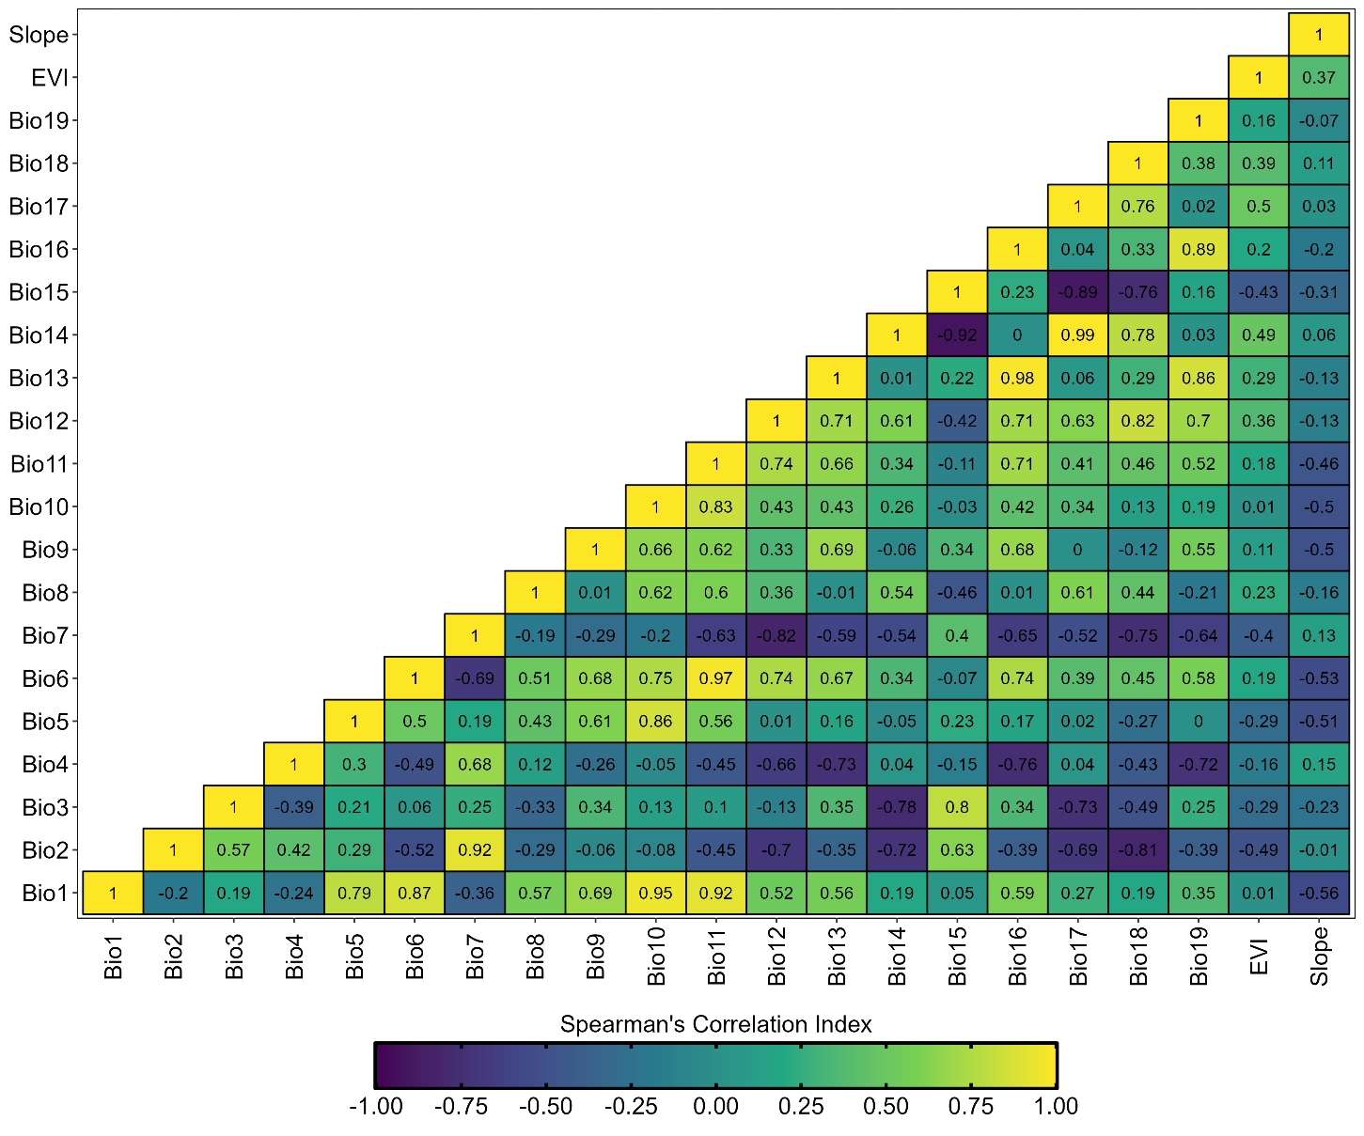

**Figure** **S2.** Projections of environmental suitability model rasters considering five thresholds. Blue dots: records located outside the model’s threshold. Yellow dots: records located inside the model’s threshold. Green polygon: original distribution of the Atlantic Forest vegetation on Brazilian Northeastern Region. Orange polygon: projection of the high environmental suitability model, based on each threshold.

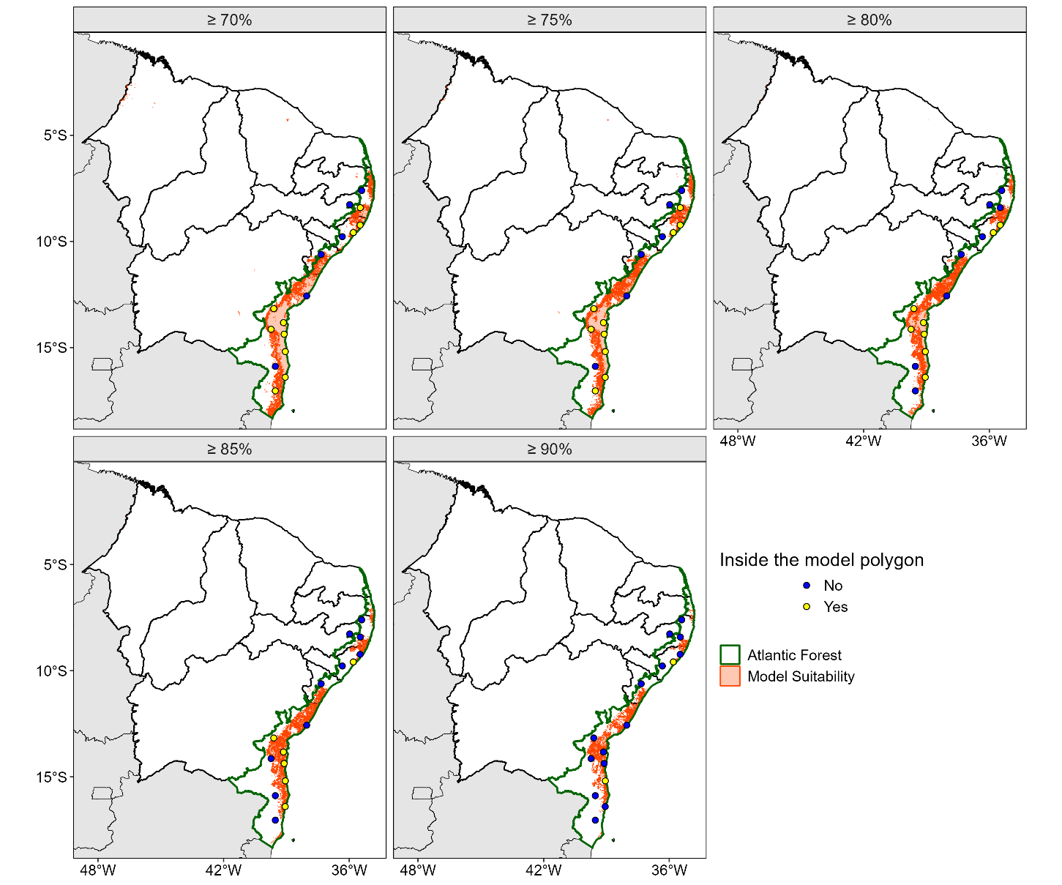

**Figure** **S3.** Distribution of the model environmental suitability values, as follows: a) percentage that each portion of the values showed over the total values of the model; and b) environmental suitability values Histogram.

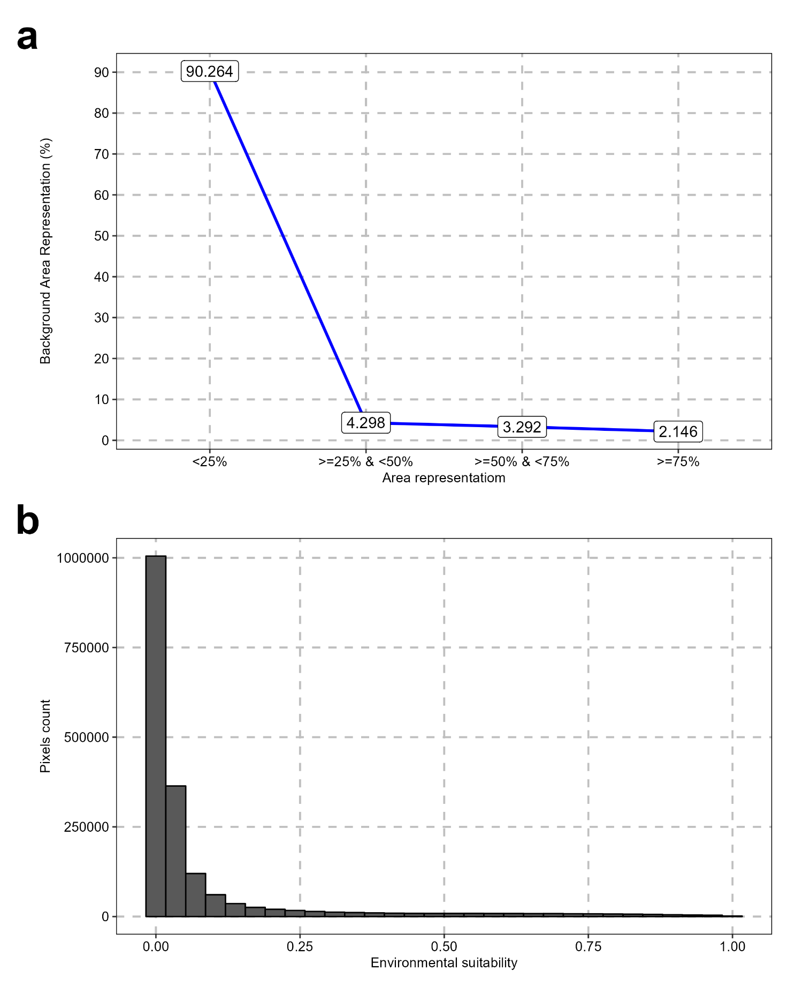

**Figure** **S4.** Importance of the predictors for the model: a) Model responses generated by each predictor; b) Response curves of each predictor.

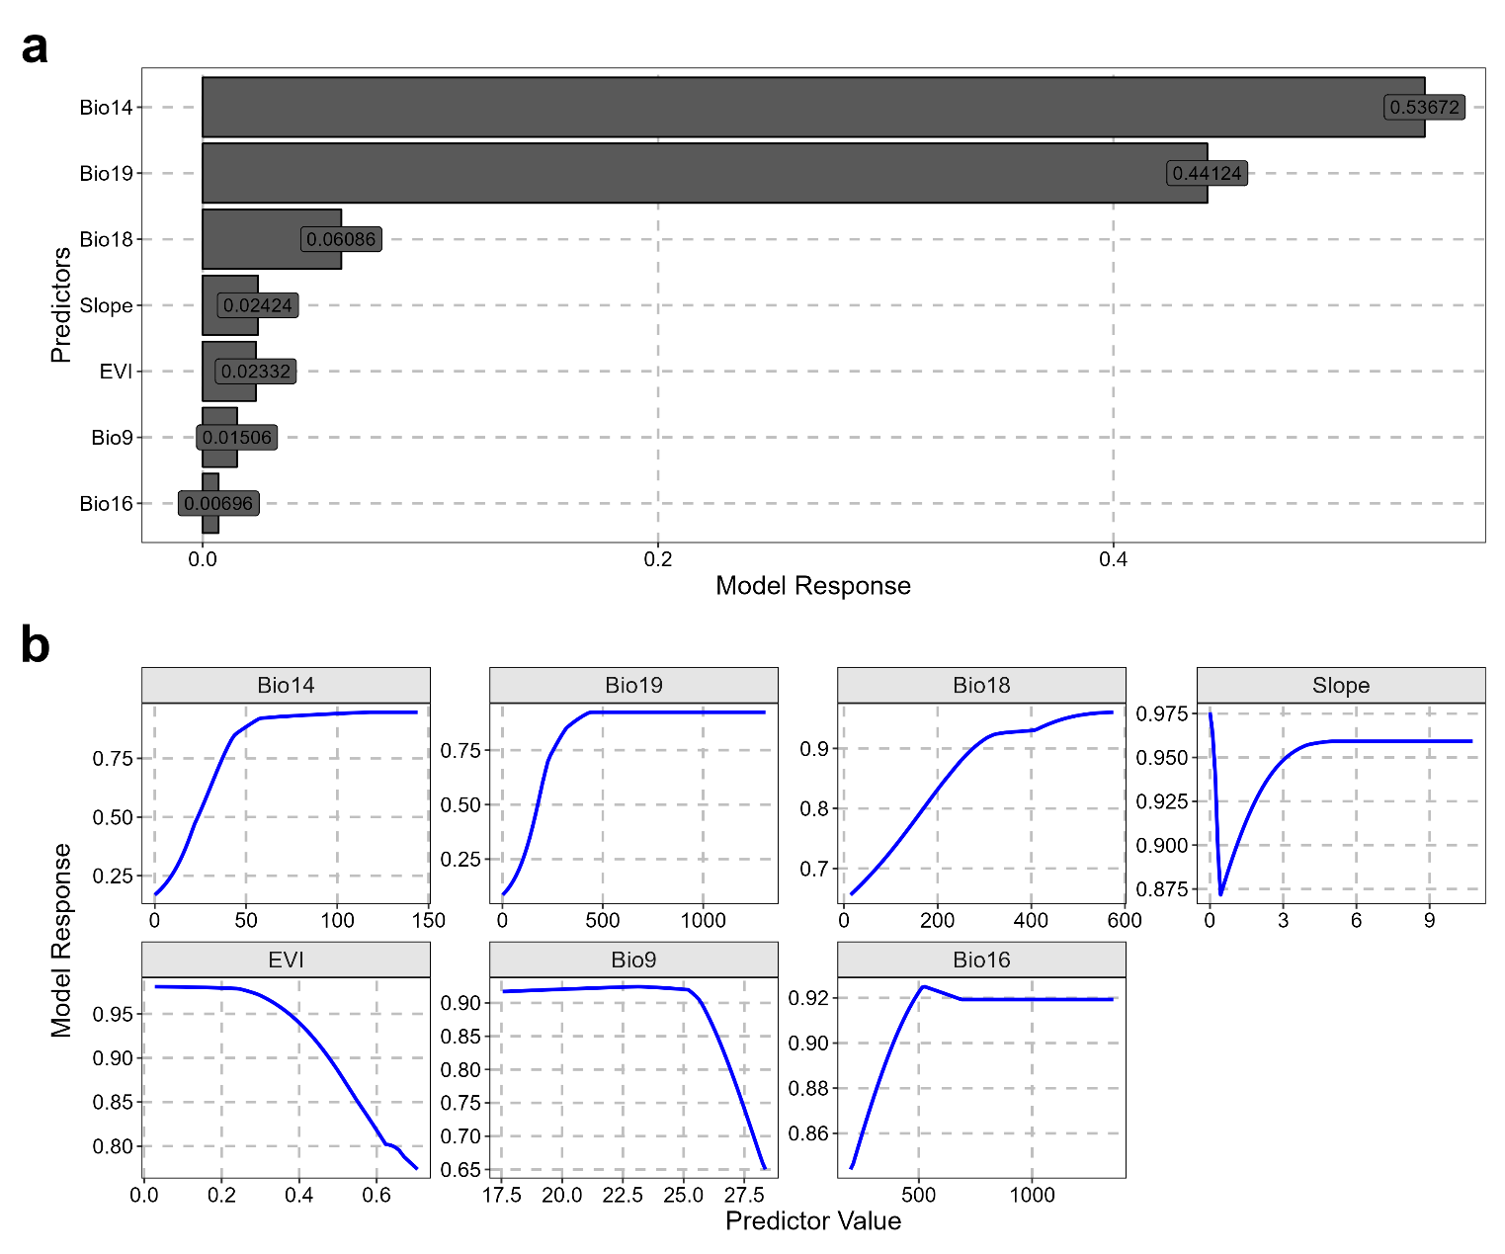

**Figure** **S5.** Current range of *Allobates olfersioides* according to the IUCN’s Red List of Threatened Species (yellow polygon) and original Atlantic Forest distribution (green polygon). Labels: Brazilian states with current or historical occurrence records of *A.* olfersioides. Blue polygon: possibly extinct *A. olfersioides* populations, from IUCN’s Red List of Threatened Species.

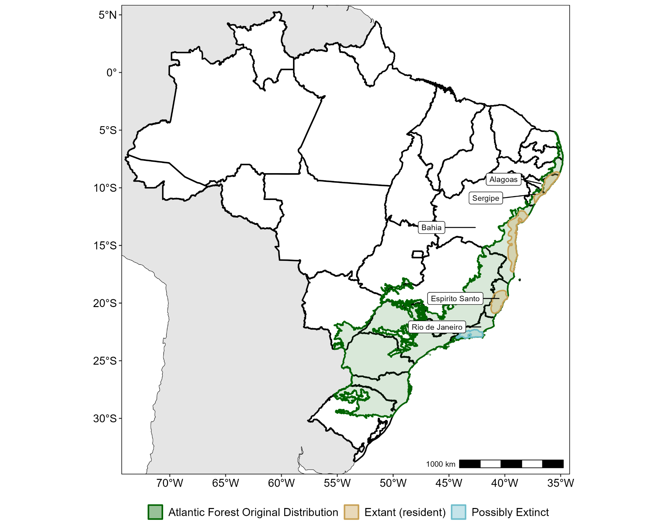

**Figure S6.** Spatial distribution of Enhanced Vegetation Index (EVI) along the Brazilian Northeastern Region. Dark/purple areas: areas of low EVI. Light/yellow areas: areas of high EVI. Orange polygon: original distribution of the Atlantic Forest vegetation on the Brazilian Northeast.

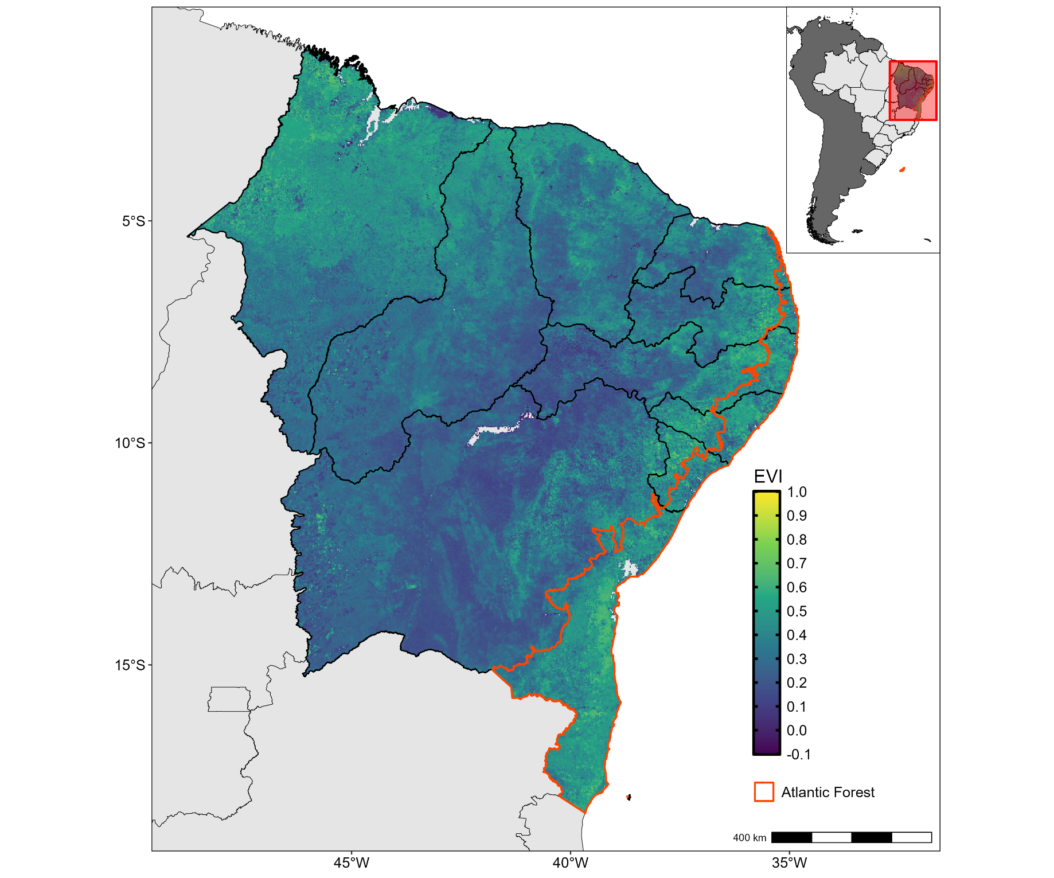

**Figure S7.** Terrain slope variation along the Brazilian Northeast. Dark/purple areas: areas of low terrain slope. Light/yellow areas: areas of high terrain slope. Orange polygon: original distribution of the Atlantic Forest vegetation on Brazilian Northeastern Region.

